|  |
| --- |
| C:\Users\user\Desktop\Draktsho logo.jpg |
| Draktsho Vocational Training Centre for Special Children and Youth |
| **Annual Report 2020** |
|  |

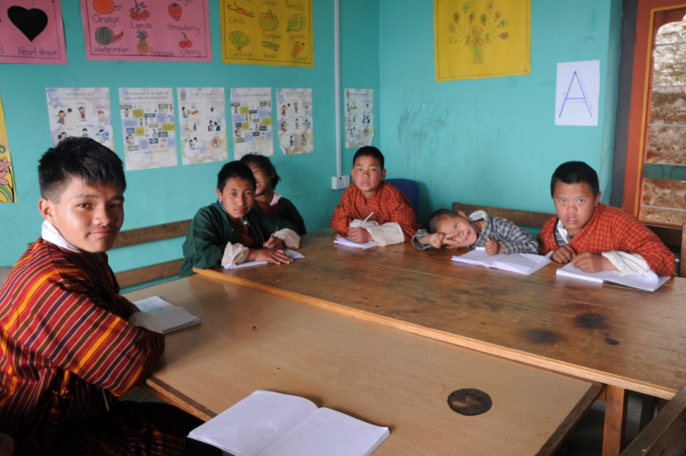

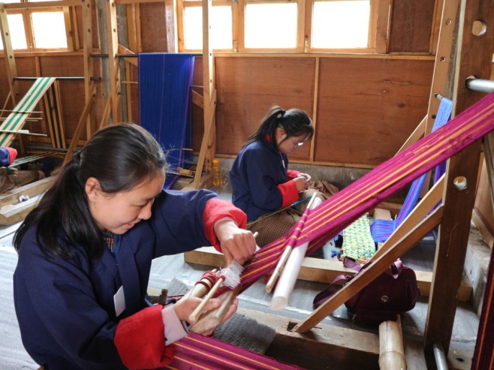 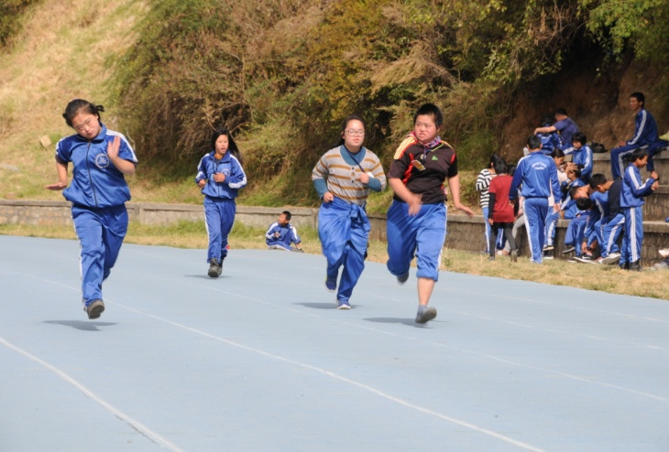

**Table of Contents Page**

1. **Foreword ...................................................................... 3**
2. **Draktsho Introduction ...................................................................... 4**
3. **Activities of the Year .....................................................................5-6**
4. **Program and Activities ................................................................................. 7-15**

**Foreword**

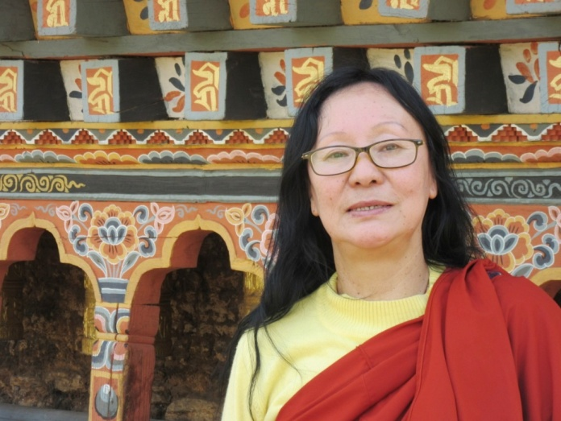

Draktsho is a pioneer in the country in the field of disability, we strongly feel responsible to tend to the need of people living with disabilities specially the children and youth who need to be guided and provided with educational, vocational and life skill training. Draktsho feels responsible to remove barriers they might face other-wise relating to accessing educational and vocational training services.

Providing services to the persons with disabilities involves huge financial resources and Draktsho has been continuously striving towards achieving financial self-reliance to support the children and youth with disabilities across the country. In order to achieve this goal, Draktsho has been trying to incorporate activities like farming and handicraft production etc. over the last few years; we are continuously researching for areas to sustain our activities.

The COVID-19 pandemic in 2020 has resulted in collapse of many businesses and institutions. Draktsho relies heavily on foreign visitors and donors to finance its activities. With the ban on travel in and out of country, one of Draktsho’s main sources of income has been completely undermined. However, with the protection and support from our guardian His Majesty the King, our people have been saved. I cannot find enough words to express our gratitude to our King for his concern and continuous work to save his people and country from the Pandemic. We the people of Bhutan are blessed to have a Noble King like Jigme Khesar Namgyel Wangchuck.

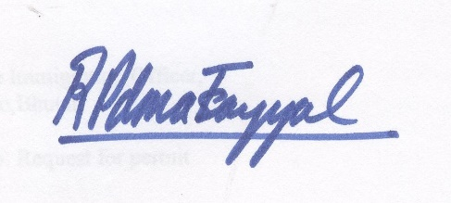

Rigzin Padma Tsogyal

Founder & Director

Draktsho

**Draktsho**

Drak-Tsho is currently the only parent initiated vocational training program in Bhutan that specifically targets children and young people who have a disability. Drak-Tsho is the first of its kind in the country; it’s a service- oriented and non-profit making centre which aspires to enhance the living standard of children and youth with disability through empowerment by training, education and eventual integration with the mainstream population. Its main focus is to equip the trainees with vocational training skills to enhance their opportunities for gainful employment. It also aims to build their self-esteem and self-reliance, thereby making them more independent, confident and contributing members of the society. The Centres (Thimphu & Kanlung, Tashigang) encompasses opportunities that allow them to grow in their aptitude, determination, goals and dreams. One of the greatest challenges for the centre is to erase the deeply embedded stigma.

The management staff of the Drak-Tsho promotes the recommendations recorded in the 2007 ‘Master Plan’. There have been a lot of activities at the Centre like the development of written curricula for life skills which would provide not only identifiable guidelines for the staff and students, but also a means of providing the basis for evaluation of the program and the progress of students. Lot of awareness raising programs have also been organized.

The first branch of Drak-Tsho, based in Kanglung, Tashigang caters the same kind of services that are taught at Thimphu Centre. Plans for including more traditional based training and conventional based training are being developed to engage every student.

## Our main objectives are:

1. To provide training in life skills including basic literacy and numeracy to persons with special needs for enabling them to cope with their daily life needs in present and future.
2. To equip trainees with special needs with vocational and work skills as preparation for sheltered, open or self-employment.
3. To facilitate the trainees with special needs secure work with dignity.
4. To initiate dialogue, build collaborations and networks with different stakeholders (government, industry, institutions etc) for actively promoting equal opportunities for people with special needs.
5. To organize parent support and community outreach program for raising awareness and generating support for inclusion of persons with special needs.
6. To conduct training, research and documentation for building human resources, supporting innovative actions and generating resource material and data for supporting quality services and advocacy.

**Activities of the year**

**3rd February**

Draktsho resumed on 3rd February following a long 2 months winter vacation.

**17th February**

The first staff meeting was held on 17th February to discuss the annual work plan of the organization as well as every sections. All teachers presented their work plan, discussed the IEP( Individualized Education Plan) of every student and the way forward.

**Workshop to enhance the Participation and Inclusion of Women with Disabilities**

The workshop on capacity development of women networks to enhance the participation and inclusion of women with disabilities was conducted on 13th and 14th November 2020

organized by Disabled Persons’ Association of Bhutan, Ability Bhutan Society, Draktsho Vocational Centre for Special Children and Youth, Bhutan Stroke Foundation and Phensem Support Group supported by United Nations Development Programme(UNDP). The participants consisted of parents of persons with disabilities, women with disabilities, service providers and UNDP who discussed how to empower women with disabilities to participate equally in the community and how to build networks with relevant stakeholders and amongst themselves. Women with different types of disabilities shared their experiences, challenges faced as a person with disability Discussions stressed on how women with disabilities are effected with regard to access to facilities, employment, other mental and physical barriers that discriminated them from participating in open forums and any other situations in life.

The service providers also shared how organizations for persons with disabilities can support, facilitate all persons with disabilities so that they can have access to all facilities and live in an inclusive society, a barrier free society.

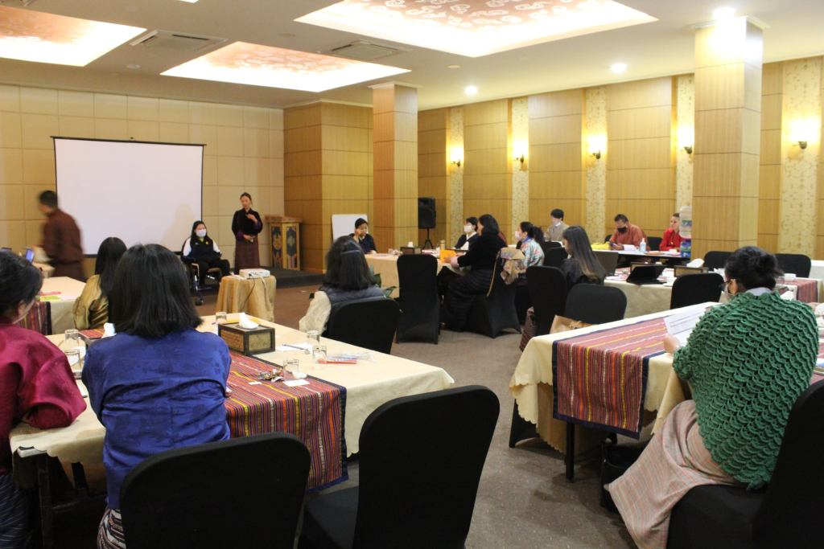 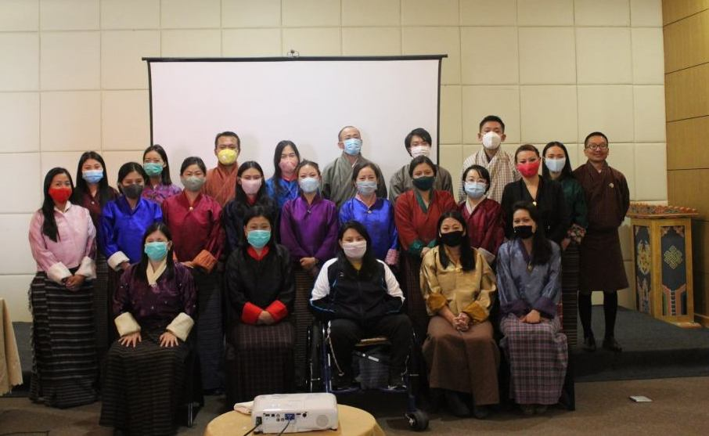

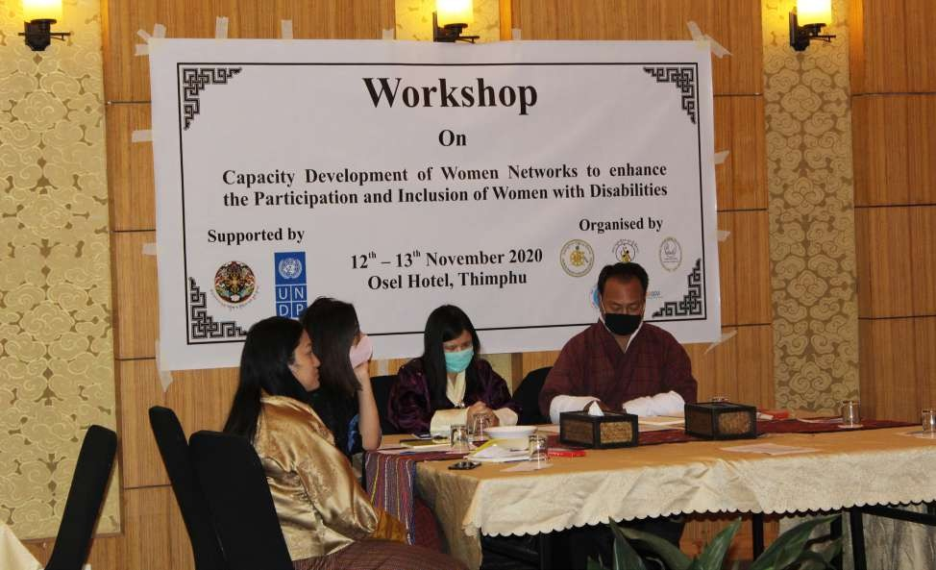

**Coordination Workshop with Organizations Working for Persons with Disabiulities**

There are 5 Civil Society Organizations Working in the area of disability, Ability Bhutan Society, Bhutan Stroke Foundation, Draktsho Vocational Training Centre for Persons with Disabilities,Disabled People's Organization and Phensum Parents Support Groupo.

Phensem with support from HELVETAS organized a coordination workshop on 16th and 17th November in Thimphu. The 5 CSOs besides presenting their SWOT analysis also deliberated on how to work together so that they can collaborate to carry out activities for more efficient and tangible results. The group worked together to develop an achievable action plan for a year, this will not just improve coordination but also strengthen each CSO individually and as a group; GNHC was present to provide feedback and play an advisory role.

This workshop was organized by Phensem Parents Support Group.

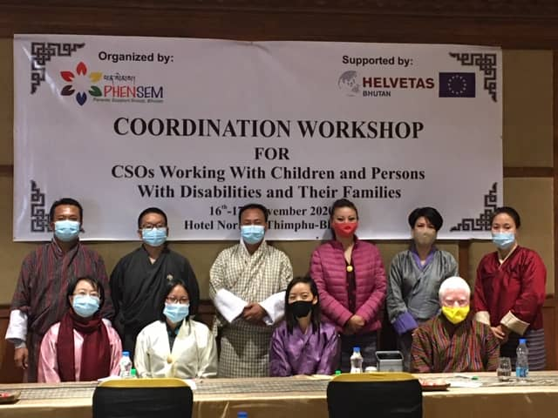

**Lockdown Services:**

Draktsho remained closed since the detection of the first COVID-19 case in March. This was followed by the nation's first lockdown which was very challenging for all especially persons with disabilities to follow the lockdown protocols. Draktsho collected donations from few individuals who were generous enough to donate edible essentials such as rice, oil, vegetables and milk to some of the families who were in dire need of such type of support. With support from Dessuups- The Guardians of Peace these essentials were dropped directly to these families of persons of disabilities. Draktsho also helped distribute Special Movement Passes to persons with disabilities so that they could at least move about within their premises with an escort. It was very challenging for children and youth with Autism, Attention Deficit Hyperactivity Disorder to remain within closed doors for days so this special movement pass really helped all persons with disabilities and also people with illness that needed outdoor activities. This would not have been possible without the support from The Gyaltsuen Ashi Jetsun Pema Wanggchuck.

**Disability Equality Training**

The Disability Equality Training was organized by three Civil Society Organizations; Ability Bhutan Society (ABS), Draktsho Vocational Training Centre for Special Children & Youth and Disabled Persons’ Association of Bhutan (DPAB) in partnership with the Gross National Happiness Commission (GNHC) and United Nation Development Program (UNDP). The training was facilitated by Persons with Disabilities (PWDs) themselves to the frontline workers of Chukha, Bumthang, Paro, Thimphu, Samdrupjongkhar, Samtse, Pemagatshel, Trongsa and Zhemgang. The aim for this training was to ensure that COVID-19 response is inclusive,raise awareness about persons with disabilities and equip the frontline workers with knowledge and skills to provide appropriate services to PWDs. The DET was initiated in 2019 where the first target audience were Taxi Association of Bhutan( taxi drivers) with the aim to create awareness about the issues/challenges faced by persons with disabilities while using public transport services. The DET turned to be a very successful program as it raised awareness about the types of disabilities and the way forward to support this vulnerable group to different stakeholders.

This project was support by UNDP Bhutan through the UNPRPD funding.

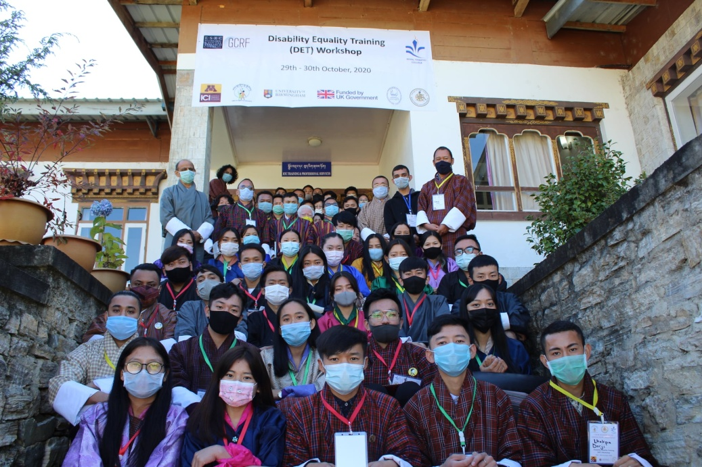

**DET Workshop at Royal Thimphu College**

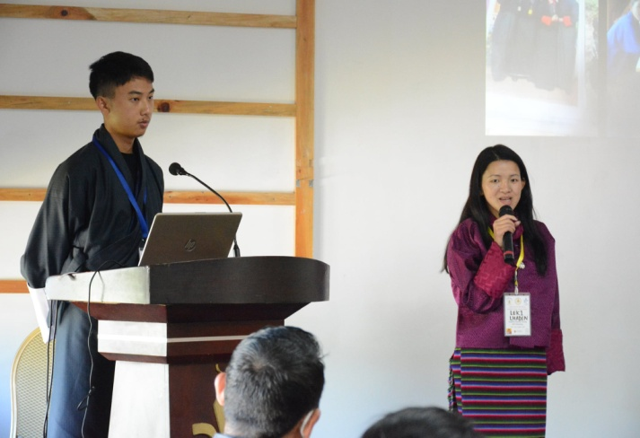 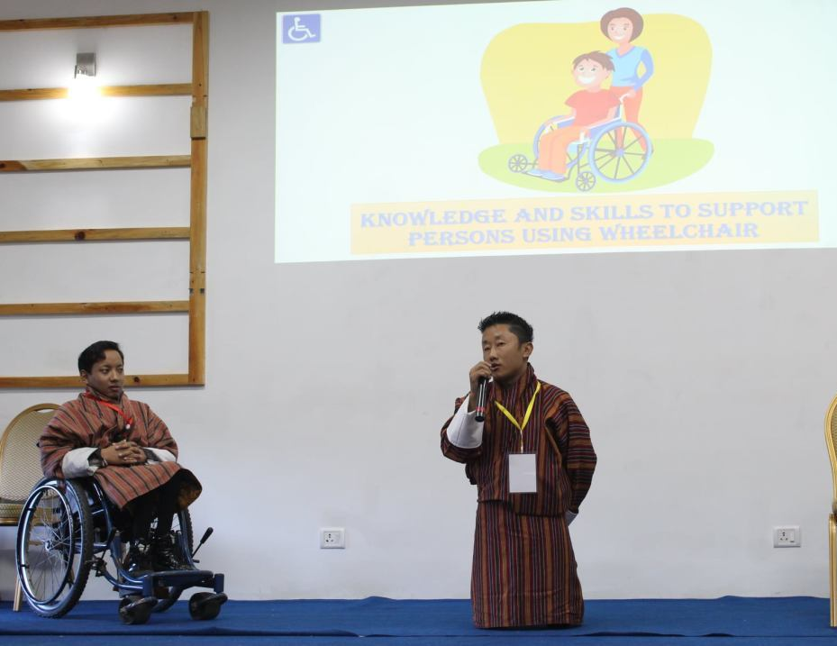

**Persons with disabilities sharing their knowledge and skills**

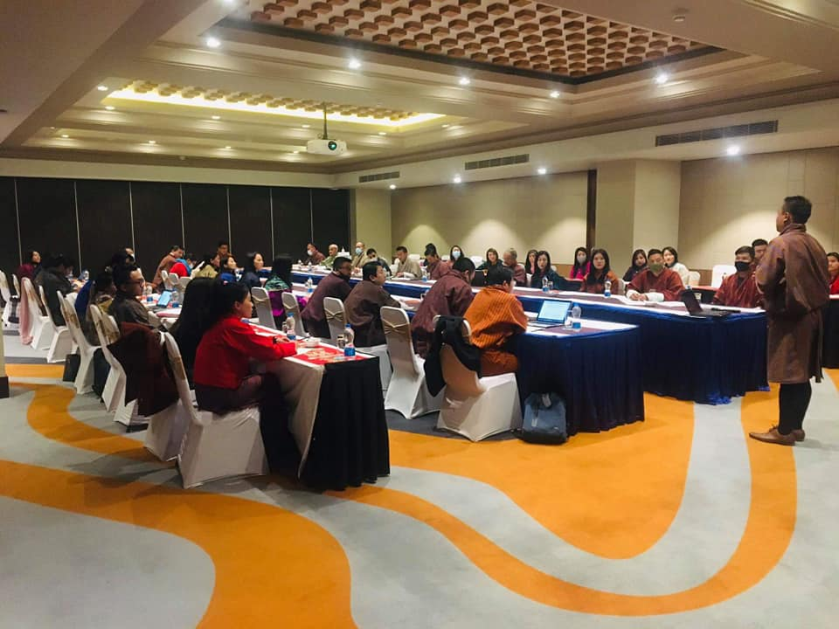

**DET workshop for Gross National Happiness Commission**

**Support from Bhutan Foundation.**

The Bhutan Foundation accepted our proposal to hire a new Special Educator for a contract of 2 years to enhance the teaching capacity of children and youth with disabilities of Draktsho. The candidates for the position were shortlisted where a date was scheduled for the interview but due to the first COVID-19 case detected on 6th March the interview was postponed. Draktsho had to remain closed for the entire year due to the pandemic that not only effected the students but also the centre as the staffs had to work on contingency plans for sustainability of the centre. Most of the local donors withdrew their pledges due to the pandemic which was very challenging for Draktsho to keep the activities at home ongoing. The funds provided by Bhutan Foundation to employ a Special Educator was utilized to procure raw materials so that the students and teachers could continue their work from home. Draktsho was indeed very fortunate to have this funding during the pandemic crisis where there was no source of income and remain ever grateful to Bhutan Foundation for the continued support.

The senior students with disabilities were provided training equipments at home along with raw materials so that they could remain engaged and employed. Raw materials were sent home so that both teachers and students could continue making face masks and other handicraft products for sustainability of the centre.

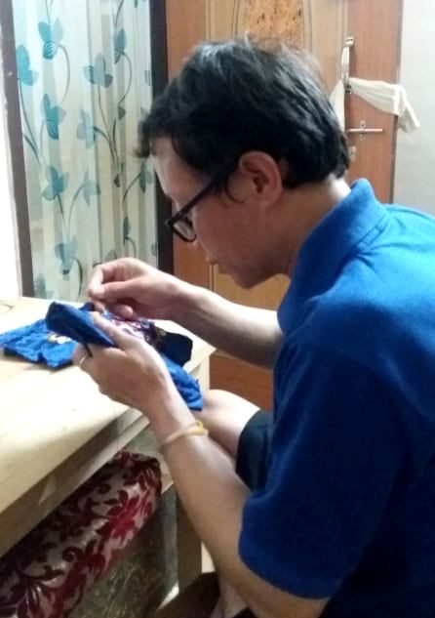 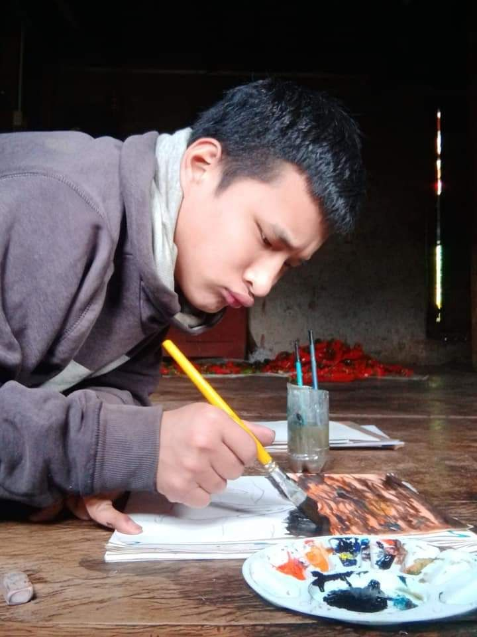

Tshering Nedup Tenzin Wangchuk inTashigang

**Home based Intervention during COVID-19 pandemic**

The COVID-19 Pandemic effected us all badly where Draktsho had to remain shut for the entire year. 2020 was one of the most challenging years as most of our funders/donors withdrew their support due to the pandemic but we had to assure that we continue our services to our children and youth with disabilities. In this regard Draktsho with support from Helvetas Bhutan provided raw materials to 10 graduates with disabilities so that they could continue working from home. The graduates' focused mostly in making face masks which were sold to various organizations and also supplied in private shops. The proceeds from the sales helped in sustaining some of its activities such as buying more raw materials in order to keep the mass production going on. All the students were also provided hand sanitizers through the same project.

The support from Helvetas Bhutan really helped Draktsho during these difficult times as both the graduates and also teachers could continue working from home sustaining their livelihoods.

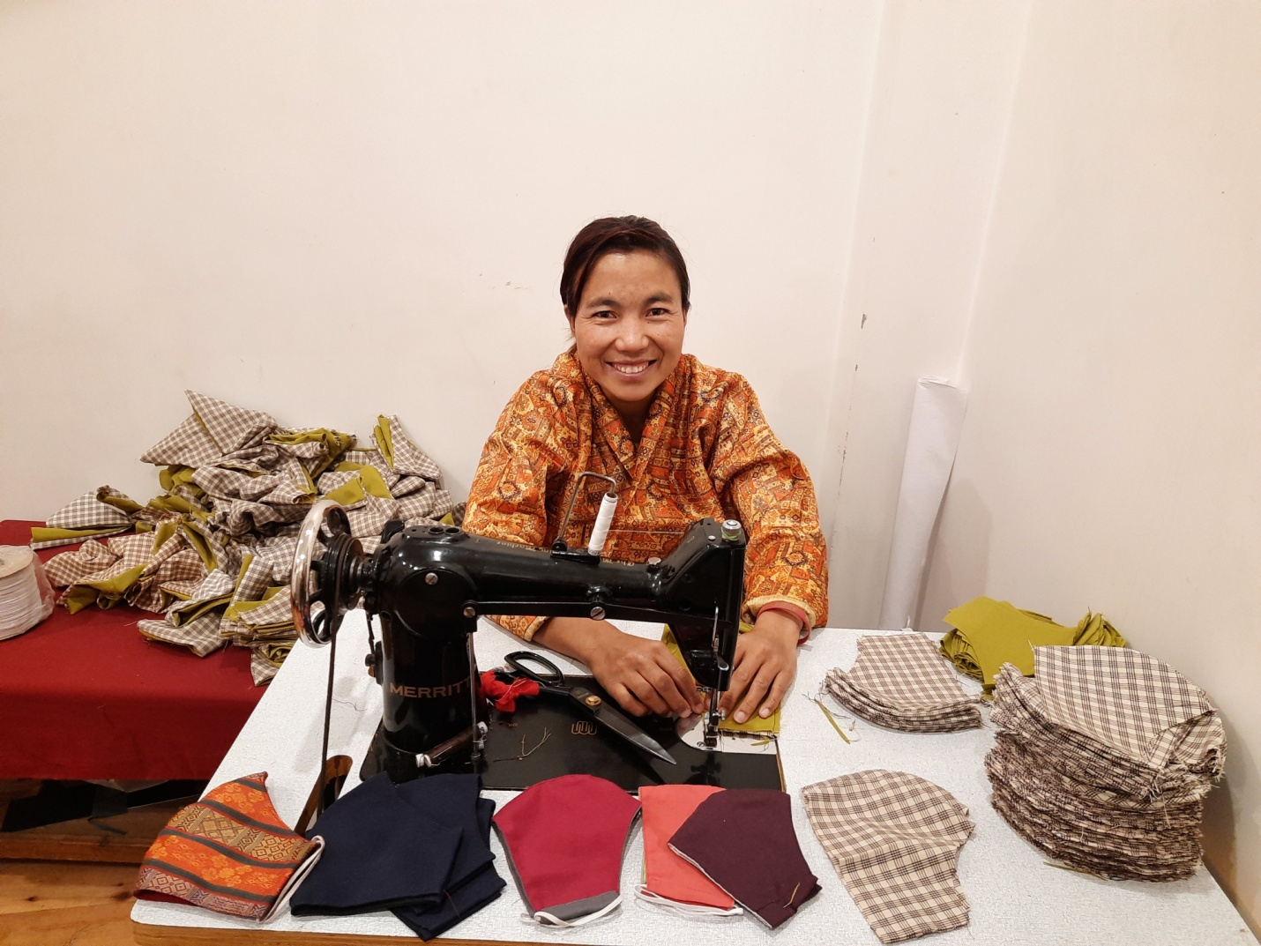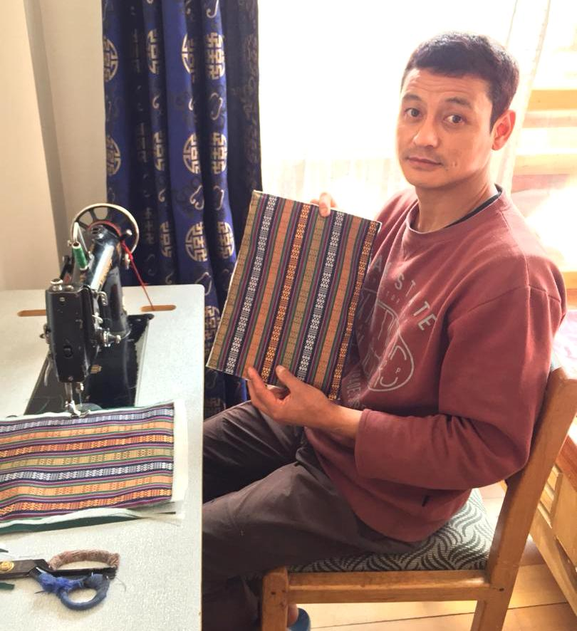

Ugyen Choden Pelden

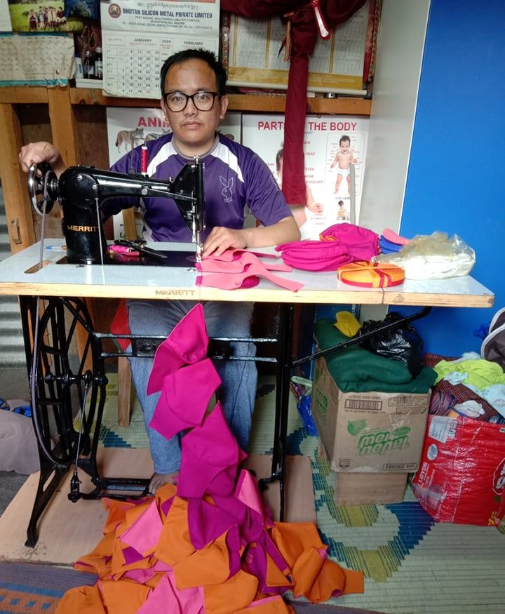 Sangay Dorji

**Program and Activities of Draktsho**

**Vocational and Co-curricular programs:**

The Vocational training and other co-curricular activities given below are some of the training programs offered at the centre. The vocational training is traditional based and which suits the capacities of the students. New skills depending on the requirement of the students are included annually.

**Main Vocational Courses offered:**

1. **Tailoring**

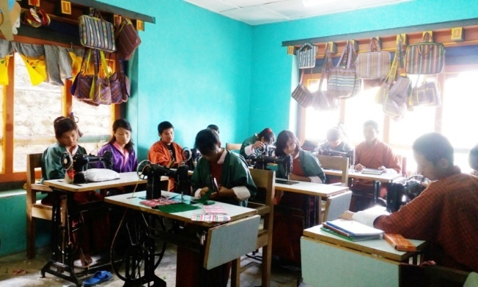 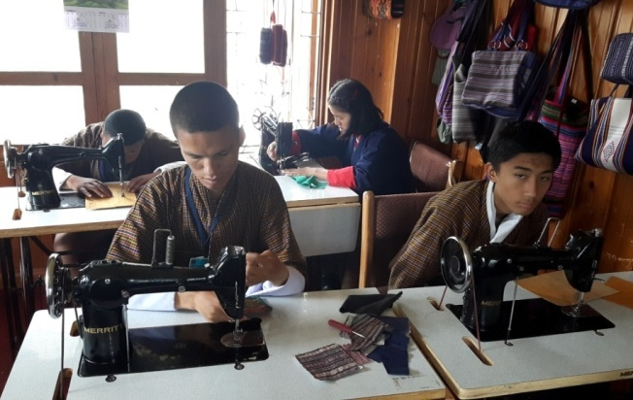

Tailoring course takes 2 to 4 years to graduate; an intellectually challenged may take more years.

1. **Traditional art and painting**

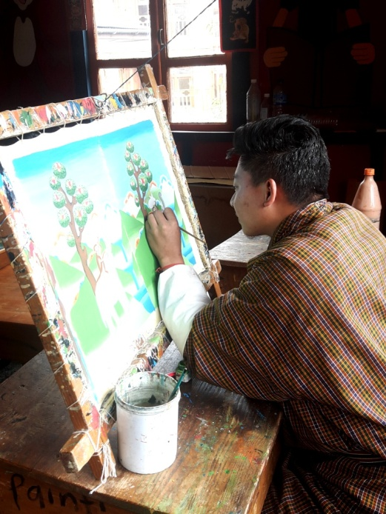 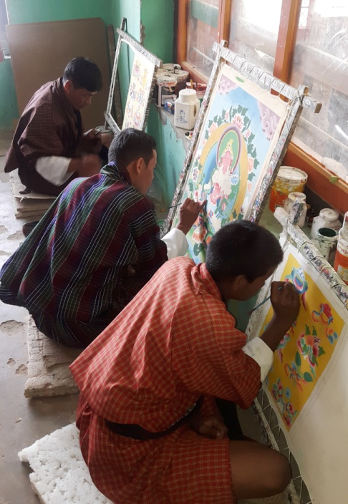

Art and painting takes 5 to 7 years to complete the course, however, it is flexible to allow the students learn at ease.

1. **Embroidery**

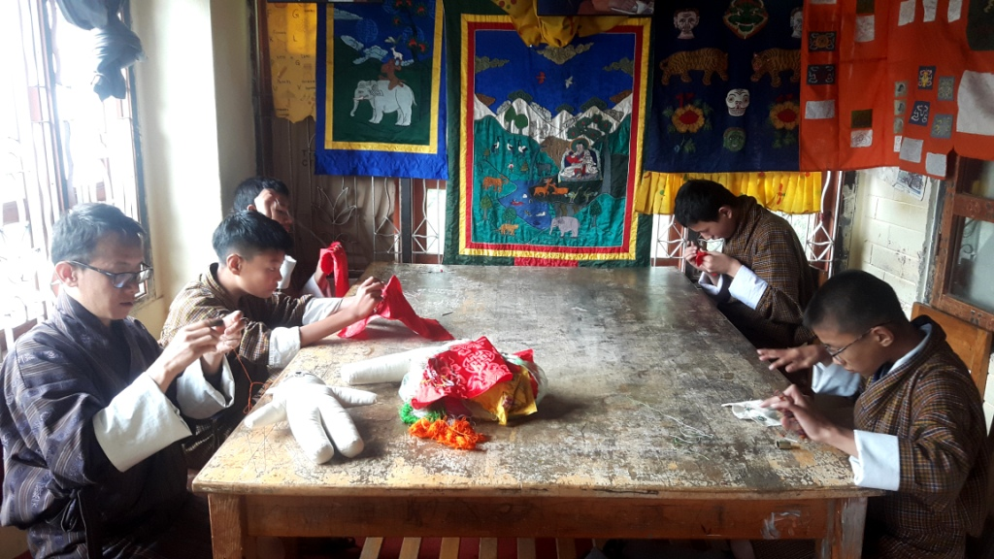

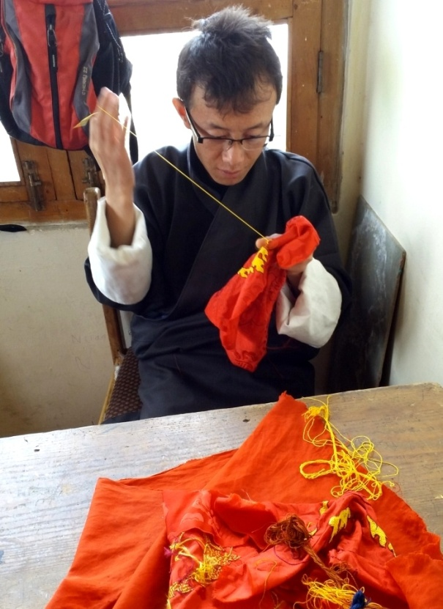

Embroidery is a high level training, it needs good hand eye coordination and good concentration. Most of the students in this class are with hearing and speaking impairment, there are few students with mild intellectual challenges. The course takes 5 to 7 years to graduate.

1. **Weaving**

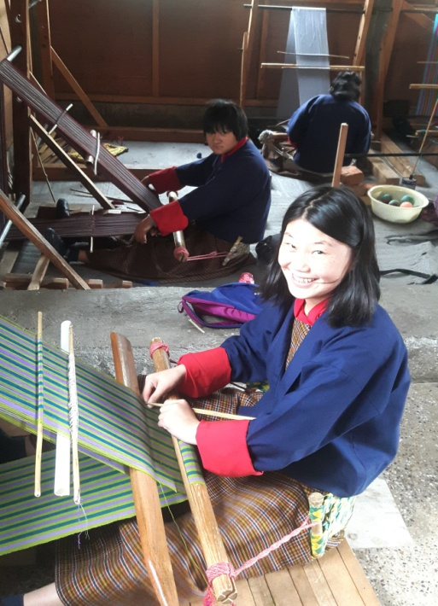 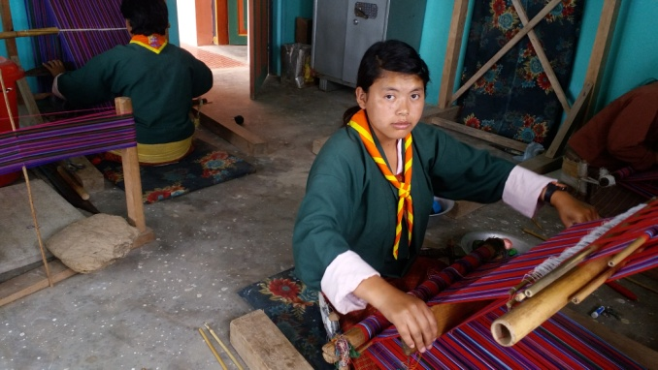

Weaving is an interesting skill development course. There are all types of youth learning weaving as it has several areas of practice. Though it is more suitable for women, men also enjoy weaving. The course takes 3 to 7 years, depending on the level of intelligence and hand coordination skills.

1. **Basket weaving(cane and plastic)**

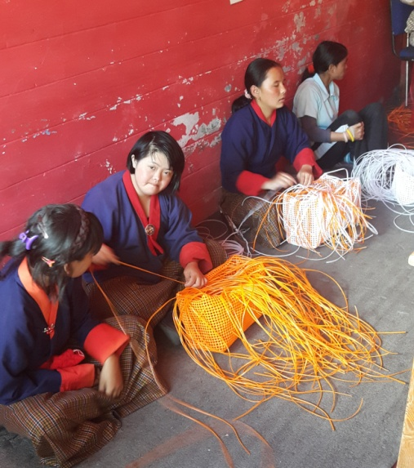 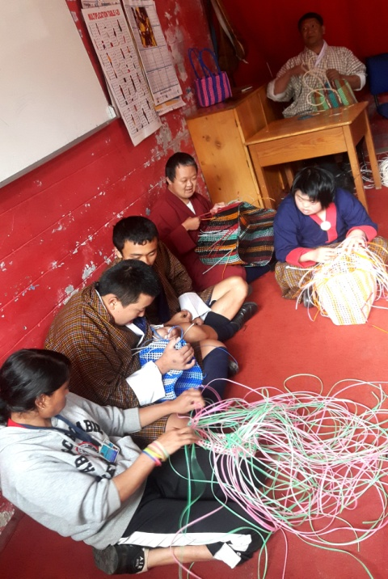

Basket weaving is pre-vocational program for Draktsho. Most of the intellectual students are placed here to determine their motor skills before transferring them to higher level training. Basket weaving develops hand eye coordination, able to sit for a long time in their seats, it also helps control behaviour problem and learn discipline.

1. **Souvenir carpentry (wood carving)**

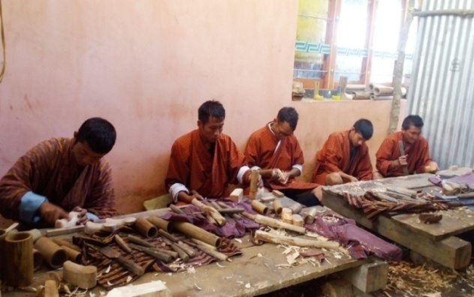 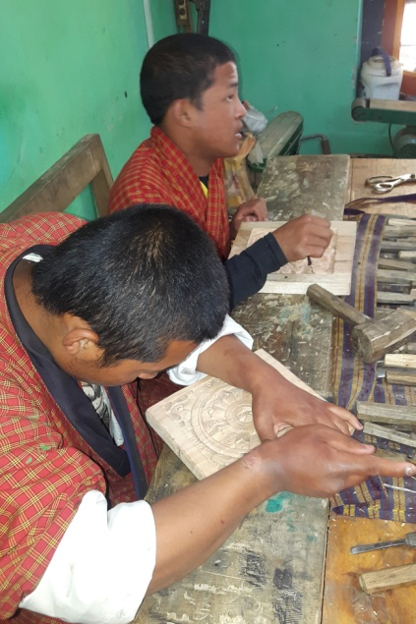 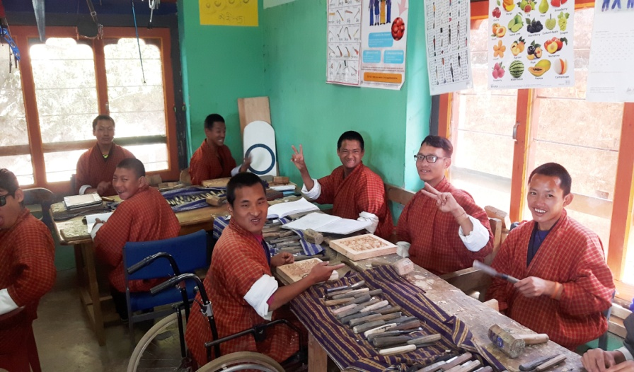

Wood carving require good hand eye coordination, besides learning carving and designing, we make small wooden souvenirs. The period of training is 5-7 years.

1. **Souvenir making(cards, bookmarks and doll making**)

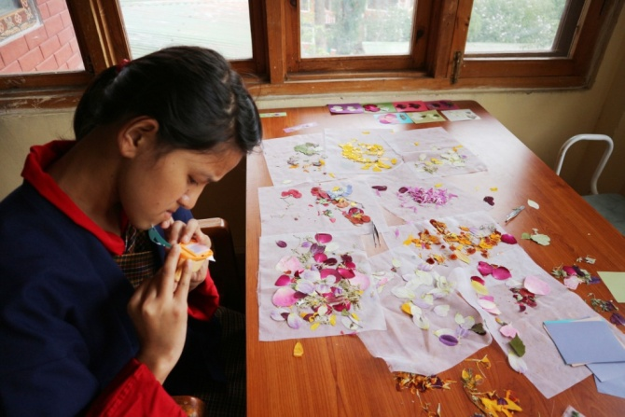

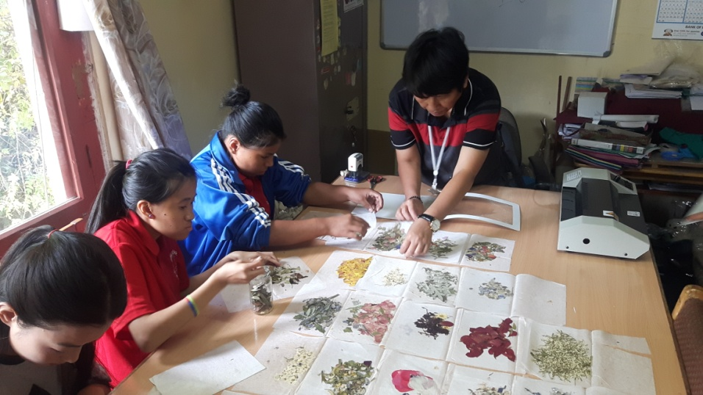

Book marks, Cards, Paper bags and boxes, small dolls are made by youth with mild cerebral palsy students. The training in this area determines the creativity of a student as they design the cards and book marks. It takes 1 to 3 years of training depending upon their individual capacity.

1. **T-Shirt and Mug Printing**

The printing training need youth with high level intelligence. We have very few students in this class.

1. **Envelope Making**

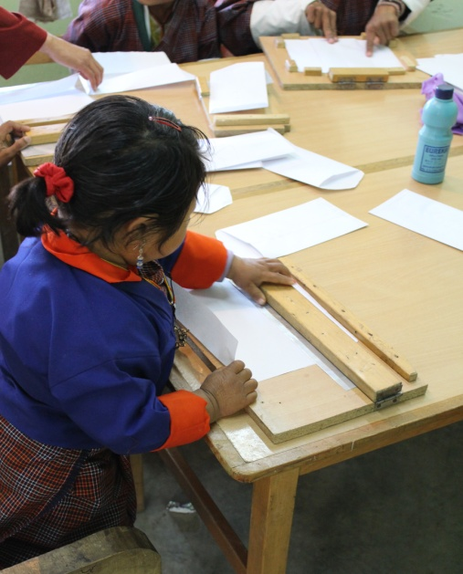 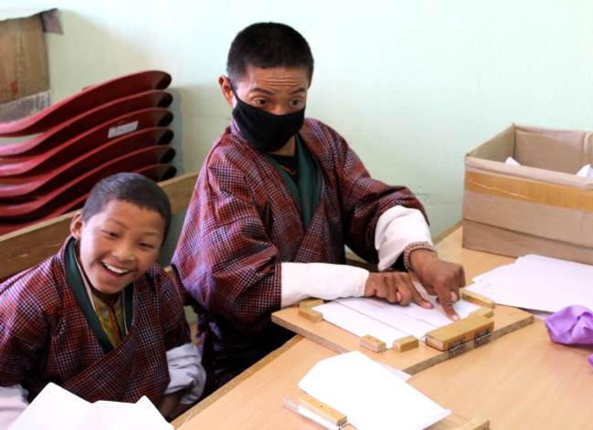

Envelopes are made by youth with moderate IQ level students and physically challenged students. It takes a group of students to complete an envelope as they lack fine motor skills.

1. **Pottery**

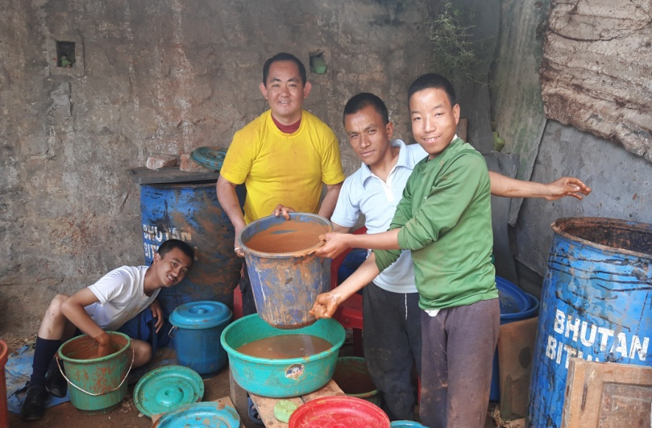 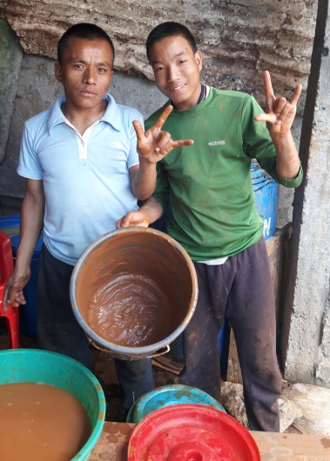

Pottery is a new skill initiated to train severely challenged students. The outcome of this training is yet to determine.

**11. Doll Making Unit**

The Doll Making Unit was initiated with support from Save the Children Bhutan with the sole purpose of engaging those students who cannot progress with other vocational trades. The doll making unit started by making traditional mini dolls and then progressed forward to make the "Four Friends" thuenpa puengzi. Draktsho started this new project so that these students could be happily engaged in something productive. There are 6 students in this unit who produce these soft cute teddy bears that are supplied to DUSIT D2 Hotel in Thimphu. This is the first of its kind production in Bhutan made by youth with disabilities.

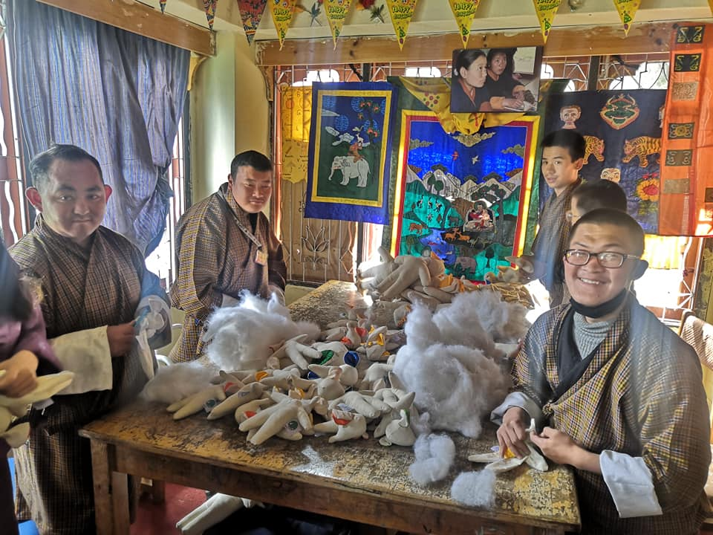

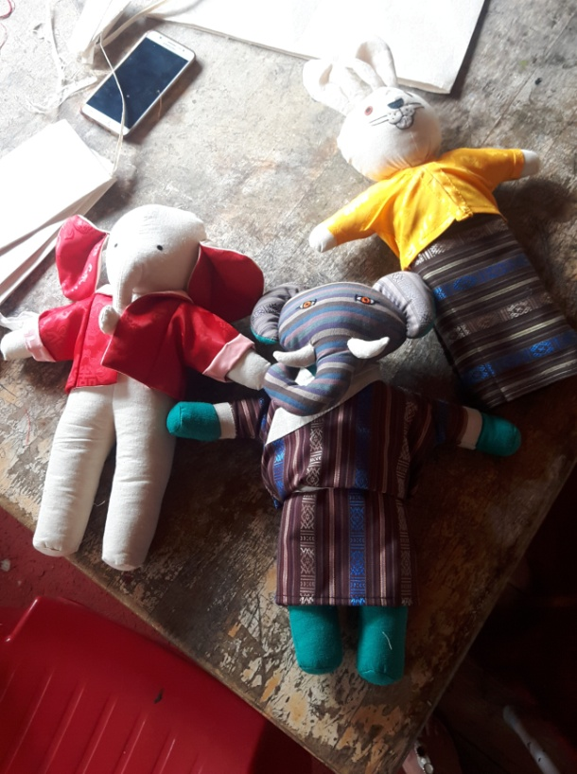 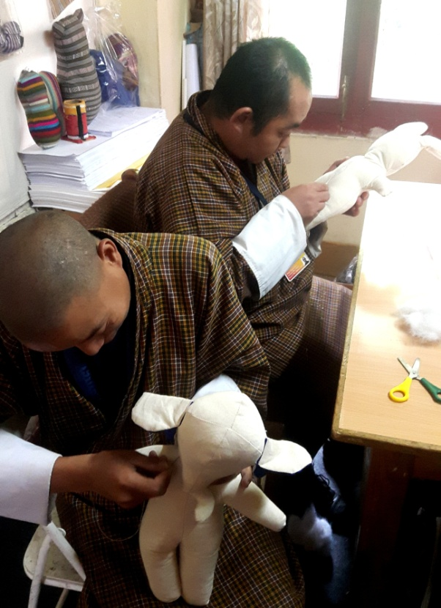

**12. Special Education:**

Special Education has always been one of the core activities of Draktsho since the beginning. The students are taught 3 subjects, English ,Maths and Dzongkha for 1and half hours every day and this is mandatory for all students. There are young children aged between 7-17 years who need Special Education and other life skills training on daily basis. Apart from basic academics the students in this unit are taught the activities of daily living(ADL) skills, social skills, singing, drawing and music to improve their behavioural and social skills.

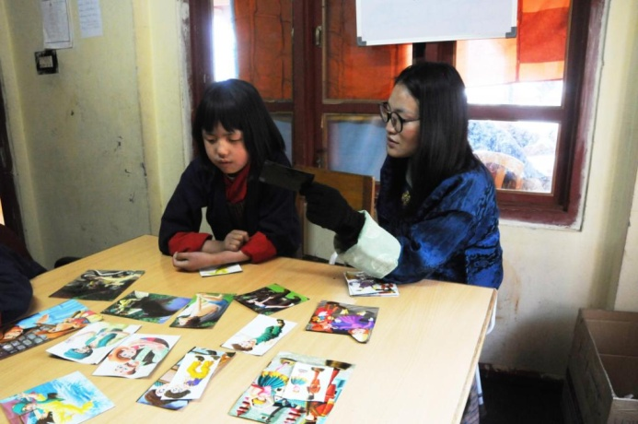 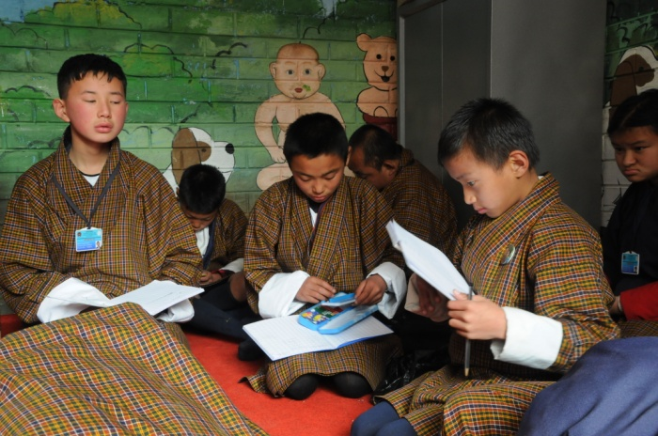

**Life skills offered:**

1. Personal management skills
2. Sign language(communication skills)
3. Social Behaviour, domestic behaviour
4. Work related or Functional Academic
5. Safety skills
6. Occupational skill and basic education(Special education)
7. Vegetable and Flower Gardening
8. Sign Language

**Co-curricular Activities:**

1. **Social skills**: dancing, singing, acting and cultural disciplinary programs are taught to the students to built their communication and socialization skills. These activities not only boost's their self esteem but also make them happy and feel inclusive.
2. **Physical fitness programs**: Draktsho is often used as the base for promoting sports for athletes with disabilities as Draktsho has maximum number of children and youth with various types of disabilities. Draktsho organizes a sports competition annually nationwide to promote the Special Olympics movement giving all special athletes a platform to showcase their abilities. This activity not only keeps one fit but brings together everyone experiencing joy, happiness, contentment and victory through inclusion.

The Special Olympics Bhutan which was founded in 2010 by people from different walks of life also operates under the umbrella of Draktsho.

In 2011, 4 athletes (2 boys and 2 girls) participated at the Special Olympics held in Athens, Greece where they participated in track and field events. The athletes won gold in the mixed relay race for the first time. Again in 2015 4 athletes with intellectual disabilities participated at the Special Olympics held in Los Angeles, California. The team brought home 6 medals (3 gold's,2 bronzes and 1 silver) in individual events. They created history in Bhutan by winning that many medals at an Olympic level. They broke barriers proving many wrong and becoming the pride of the nation.

1. Apart from the vocational training, educational and life skill program, the students are also given opportunities to development individually through counseling, personal coaching and guidance.

Following one of its long term goals Draktsho has successfully established its first branch in Kanglung,Tashigang. The centre is known as Draktsho East Centre and unlike the centre based in Thimphu it provides boarding facilities to 130 students. The students at Draktsho Thimphu are day scholars and at present there are 210 students (137 boys and 73 girls) in total.

We continue to reach out to the needy and are always looking for avenues to cater our services for all.

Thank You,

Deki Zam,

Executive Director

Draktsho

Email. [dekzang@hotmail.com](mailto:dekzang@hotmail.com)

Mob: 77273144